

##### Question/Answer Booklet

Name:

Yr 11 ATAR PHYSICAL EDUCATION STUDIES

Exercise Physiology Class Test 2020

**Time allowed for this paper**

Working time for paper: 45 minutes

**Material required/recommended for this paper**

*To be provided by the supervisor*

This Question/Answer Booklet

|  |  |  |  |
| --- | --- | --- | --- |
| **Contents:**  Exercise Physiology | Multiple choice  Short answers  Extended questions | 10 marks  40 marks  10 marks  **Total marks** | **/60** |

**Circle the correct letter/answer:**

**Multiple Choice (10 marks)**

1. 45 seconds into a 1500m run, which energy system would be providing the highest proportion of energy for ATP production?

(a) ATP-CP

(b) Lactic Acid

(c) Aerobic

(d) Anaerobic

2. An increase in cardiac output is a direct response of the increase in both:

(a) blood pressure and tidal volume

(b) blood pressure and stroke volume

(c) heart rate and tidal volume

(d) heart rate and stroke volume

3. An elite junior basketball player wanting to improve their vertical leap and rebounding ability would be best advised to undertake:

(a) fartlek training

(b) continuous training

(c) interval training

(d) plyometric training

4. Rate of perceived exertion, percentage of heart rate maximum and percentage of VO2 maximum are all valid measures for which principle of training?

(a) specificity

(b) intensity

(c) duration

(d) progressive overload

5. After completing a battery of fitness tests, an athlete was able to identify his strengths and weaknesses in the table below.

|  |  |
| --- | --- |
| **Strengths** | **Weaknesses** |
| * Agility * Balance * Reaction time | * Muscular strength * Power * Speed * Cardiorespiratory endurance |

Based on the results in the table above, the athlete is most likely a:

(a) long distance runner

(b) mixed martial artist

(c) surfer

(d) shot putter

6. Which of the following is **not** a long-term adaptation to physical activity?

1. Decrease in resting heart rate.
2. Decrease in stroke volume at rest.
3. Decrease in cardiac output at rest.
4. Increase in blood volume at rest.

7. The primary energy system used during a javelin throw is:

1. Aerobic energy system.
2. Lactic acid energy system.
3. Anaerobic glycolysis energy system.
4. ATP-CP energy system.

8. In their first session, a personal trainer asks their client to perform as many push ups as possible in one minute. This test is designed to primarily measure the client’s:

1. Muscular strength.
2. Cardiorespiratory endurance.
3. Power.
4. Muscular endurance.

9. The athletes in the picture below are participating in which type of training?

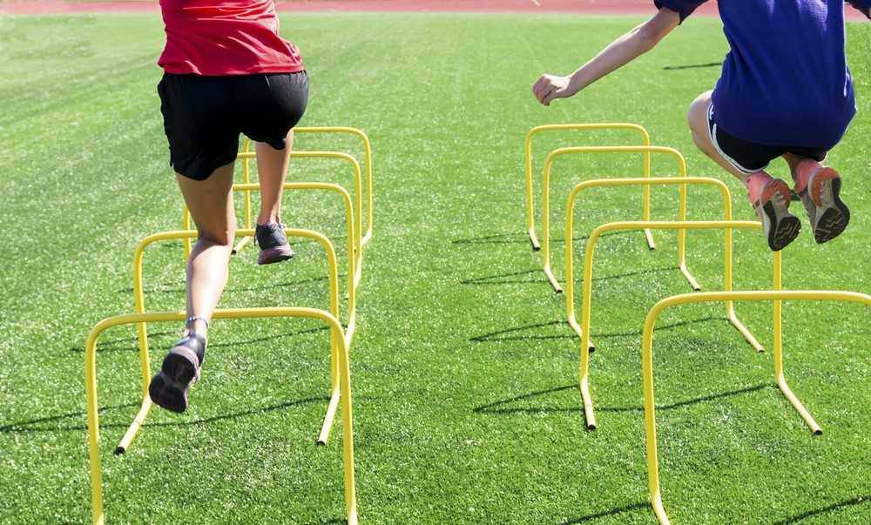

1. Flexibility training.
2. Plyometric training.
3. Fartlek training.
4. Interval training.

10. “If you don’t use it, you lose it” best describes which training principle?

1. Intensity.
2. Specificity.
3. Progressive overload.
4. Reversibility.

**Short Answer (40 marks)**

**Question 11. (9 marks)**

Below is Simon’s regular training program that he has been undertaking for the past six months.

|  |  |  |  |  |  |  |
| --- | --- | --- | --- | --- | --- | --- |
| **Monday** | **Tuesday** | **Wednesday** | **Thursday** | **Friday** | **Saturday** | **Sunday** |
| 5km jog | 1 hour yoga session | Rest day | Swimming  (20 x 50m sprints with 1 min rest) | Rest day | Rest day | Rest day |

In the table below:

1. Identify the training types that are evident in Simon’s exercise program.

(3 marks)

(b) Identify the fitness component relevant to each training type in Simon’s exercise program.

|  |  |  |  |
| --- | --- | --- | --- |
|  | **Monday** | **Tuesday** | **Thursday** |
| **Training type** | Aerobic  Continuous training  1 mark | Flexibility training  1 mark | Interval training  speed  1 mark |
| **Fitness component** | 1 mark for any of the following:  Cardiorespiratory endurance  Muscular endurance | 1 mark for any of the following:  Flexibility | 1 mark for any of the following:  Cardiorespiratory endurance  Power  Speed |

(3 marks)

**(c)** Simon is training to compete in a community 5km fun run in six months. Explain why the program is inadequate in terms of three principles of training that have not been correctly applied. (3 marks)

|  |  |
| --- | --- |
| Student can pick any **three** of the following:  **Specificity**   * Complete more 5km runs * More aerobic energy system-focussed training * Any other relevant application to scenario   OR  **Frequency**   * Increase cardiovascular sessions to 3-4 per week * Any other relevant application to scenario   OR  **Progressive Overload**   * Gradually increase the time/distance to achieve more adaptations * Any other relevant application to scenario   OR  **Duration**   * Ensure exercise lasts for a similar time to the duration of a 5km jog * Any other relevant application to scenario | 1 mark per principle of training (must be three different principles of training)  1 mark per suggestion related to principle and program |

**Question 12 (6 marks)**

Josie is a goal keeper for her soccer team in a competition on Saturday mornings. The table below details her diet in the lead up to her game, during and post-event.

|  |  |
| --- | --- |
| **Friday night** | Spaghetti Bolognese  Banana and custard |
| **Breakfast**  **(2 hours before game)** | 1 piece of toast with peanut butter  1 x 250mL chocolate milk  1 x 250mL water |
| **Before game**  **(15 mins before)** | 1 x muesli bar  250mL water |
| **During game** | 500mL water  2 x lollies (snakes) |
| **Lunch**  **(30 minutes after game)** | 250mL water  1 banana  1 x large hot chips |

Suggest three improvements that Josie could make to her diet, providing reasons for your choices. (6 marks)

Student can discuss any **three** improvements with appropriate reason. Examples include:

* More carbohydrates for breakfast, as this will be main fuel source during activity
* Eat at least three hours before the game for adequate fuel to be available.
* If required, eat small snack one hour before the game to top up fuel stores.
* Replace recovery meal with protein and more energy dense carbohydrates to replace fuel lost.
* Drink more water the night before OR after the match for adequate re/hydration (can only mention one, not both)

**Question 12 (6 marks)**

Josie is a goal keeper for her soccer team in a competition on Saturday mornings. The table below details her diet in the lead up to her game, during and post-event.

|  |  |
| --- | --- |
| **Friday night** | Spaghetti Bolognese  Banana and custard |
| **Breakfast**  **(2 hours before game)** | 1 piece of toast with peanut butter  1 x 250mL chocolate milk  1 x 250mL water |
| **Before game**  **(15 mins before)** | 1 x muesli bar  250mL water |
| **During game** | 500mL water  2 x lollies (snakes) |
| **Lunch**  **(30 minutes after game)** | 250mL water  1 banana  1 x large hot chips |

Suggest three improvements that Josie could make to her diet, providing reasons for your choices. (6 marks)

|  |
| --- |
|  |
|  |
| Student can discuss any **three** improvements with appropriate reason. Examples include:   * More carbohydrates for breakfast, as this will be main fuel source during activity * Eat at least three hours before the game for adequate fuel to be available. * If required, eat small snack one hour before the game to top up fuel stores. * Replace recovery meal with protein and more energy dense carbohydrates to replace fuel lost. * Drink more water the night before OR after the match for adequate re/hydration (can only mention one, not both) |

**Question 13 (2 marks)**

In preparing the tournament matches, tennis players have to consider their nutrition prior to matches to maximise their performance and prevent early onset of fatigue.

Explain the difference between high and low GI carbohydrates including when a player is most likely to consume them **prior** to competing in a match.

|  |  |
| --- | --- |
| **Description** | **Max 2 Marks any 2** |
| High GI Carbohydrates break down quickly during digestion and have a high glycaemic index (GI more than 70) releasing their glucose into the blood quickly. | 1 mark |
| Low GI Carbohydrates break down slowly and have low glycaemic index (GI less than 55) releasing glucose gradually into the bloodstream. | 1 mark |
| High GI Carbohydrates best consumed only in the **immediate minutes** (less than 15min) prior the event to ‘top-up’ glycogen levels eg. after completing a pre-match warm-up. | 1 mark |
| Low GI Carbohydrates best consumed as a pre-match meal (**1-4hrs prior to competition**) | 1 mark |

**Question 14 (7 marks)**

The graph below displays the interplay of the three energy systems that provide ATP for a runner at the start of their race.

(a) Label the three curves in the boxes provided, identifying each energy system.

(3 marks)

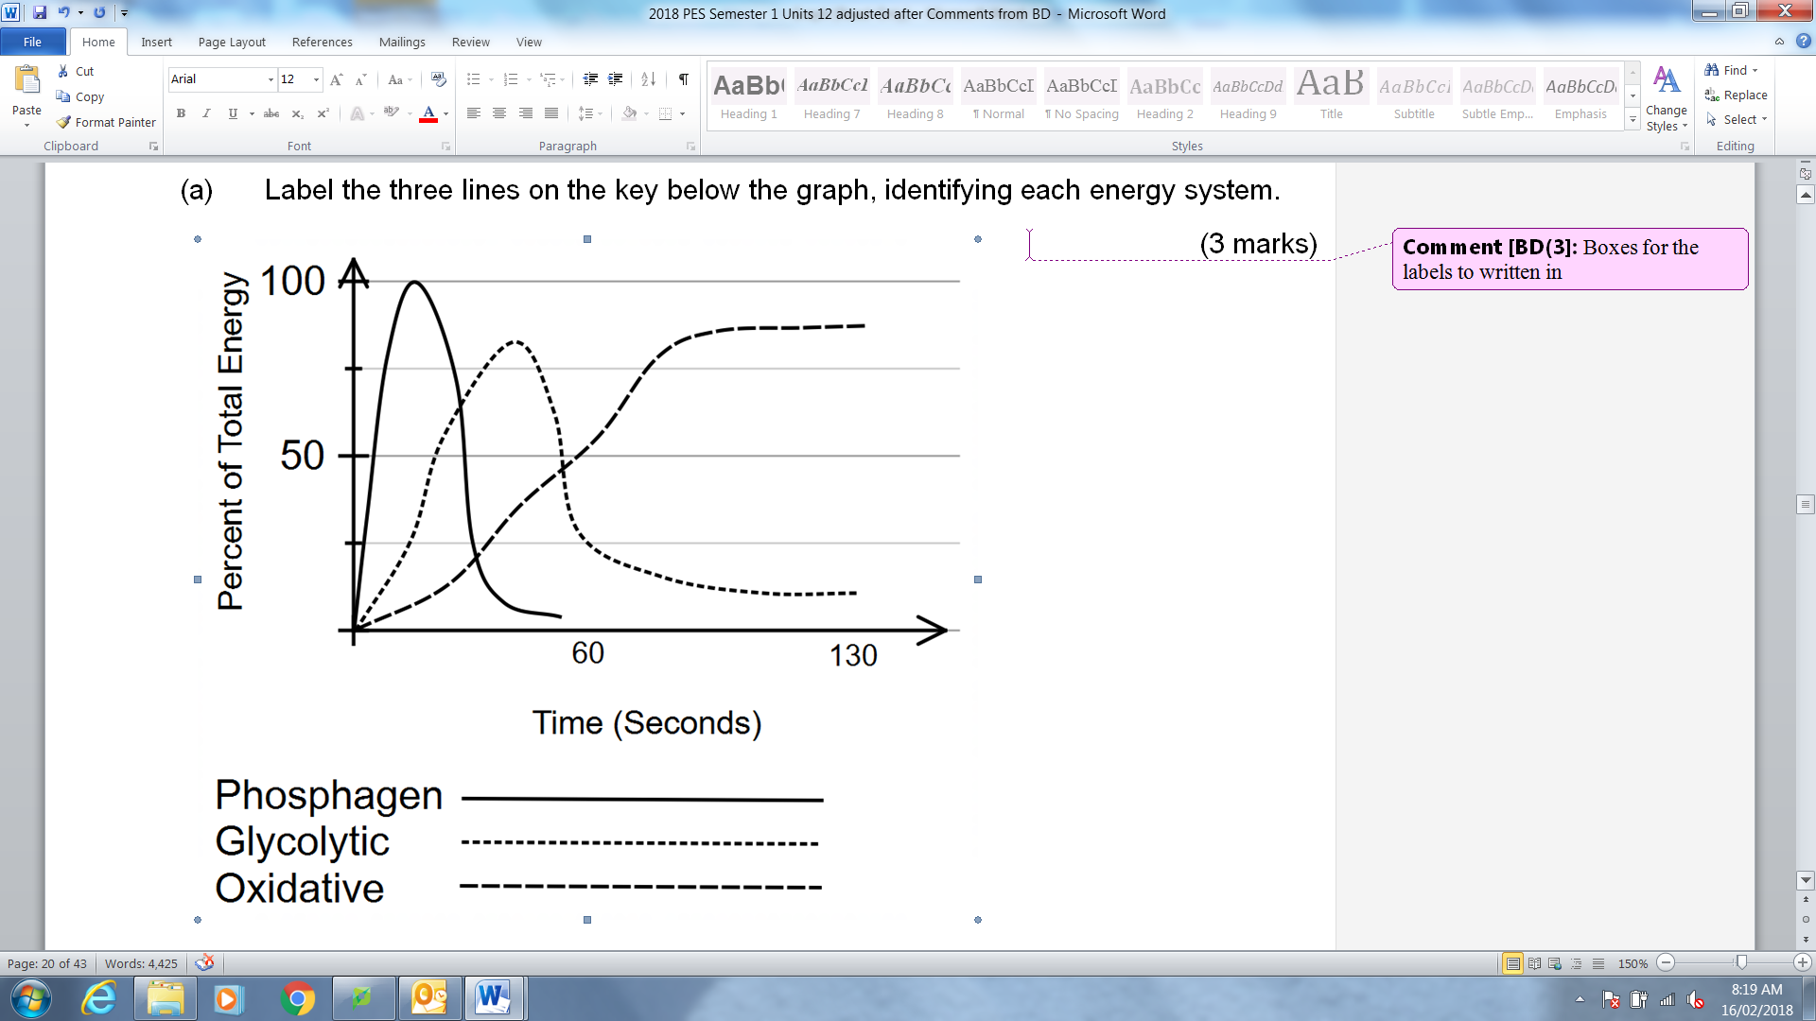

Lactic Acid

ATP-CP

Aerobic

|  |
| --- |
| 1. There are 2 pathways for energy production, name the 2 pathways and state which one requires oxygen and which one does not.   **Aerobic – oxygen** |
| **Anaerobic – NO OXYGEN** |

(1 mark)

1. Referring to the graph in part (a), explain the contribution of each energy system in providing ATP for the runner in the first 130 seconds of the race.

|  |  |
| --- | --- |
| **Marks** | **Elaboration** |
| 1 mark  1 mark  1 mark | ATP-CP provides majority of the ATP for the first 10 sec of the race  Lactic Acid system provides majority of the ATP from the 10sec mark to the 30sec mark  Aerobic System provides majority of the ATP for the race from the 30sec mark onwards |

**Question 15 (6 marks)** In order to improve her strength, power and overall performance in long jump, Tiffany has undertaken a training program that requires her to perform exercises like squats, lunges, bicep curls and bench press using heavy weights. She generally performs three sets of ten reps of each exercise.

(a) Identify the type of training Tiffany is utilising.

Resistance /strength ___________________________

(1 mark

(b) Tiffany’s training program incorporates exercises that cause her muscles to contract in different ways. Referring specifically to muscle actions, complete the blank spaces in the table below.

|  |  |  |
| --- | --- | --- |
| **Muscle action Type** | **Description** | **Example** |
| Eccentric | An exercise performed against a resistance where the muscle is lengthening during contraction | down movement of bicep curl |
| Isometric | When there is a resistance applied to the muscle and the muscle length not change | Plank or bridge |
| Concentric | An exercise performed against a resistance where the muscle length shortens during contraction |  |

(5 marks)

**Question 16 (4 marks)**

An aspiring young boxer has enlisted the help of a professional coach in the hope of improving his physiological capacity and overall performance. Explain **two (2)** training principles that this coach should follow for best possible results and how each principle could be applied to a boxing context.

1 mark for explaining principle, 1 mark for applying principle to a boxing context. Choose from;

|  |  |
| --- | --- |
| **Marks** | **Elaboration** |
| 1 mark  1 mark | *Specificity*  Explanation – Ensure training targets the movements, muscles and energy systems utilised in the athlete’s particular sport  Application – Coach should incorporate both aerobic and anaerobic training or full contact sparring / not just pad exercises or incorporate training for power as well as endurance |
| 1 mark  1 mark | *Intensity*  Explanation – Ensure training is structured so that the athlete’s training effort or exertion is appropriate for physiological gain  Application – Coach should incorporate both aerobic (65-85% MHR) and anaerobic training – high intensity (<85% MHR) |
| 1 mark  1 mark | *Duration*  Explanation – Ensure training is structured so that the athlete trains for long enough for physiological gains to occur  Application – Coach should ensure all training sessions last at least 20 mins (longer sessions should be less intense) or Coach should ensure training program is long enough for fitness gains (ie start training program at least 12 weeks before each fight) |
| 1 mark  1 mark | *Frequency*  Explanation – Relates to the number of training sessions completed per week. Minimum of 3 sessions p/w required for physiological gains to occur. Endurance athletes should train more sessions per week than anaerobic athletes  Application – Coach should schedule approx. 4-6 sessions per week to ensure adaptations occur and sufficient recovery is included |
| 1 mark  1 mark | *Progressive Overload*  Explanation – The gradual and regular increase in training workload to ensure fitness adaptations continue to occur.  Application – Coach will regularly increase the workload of training sessions by increasing the duration/frequency or intensity of training. A gradual increase of no more than 10% per week is adequate |
| 1 mark  1 mark | *Reversibility*  Explanation – The loss of physiological conditioning that occurs as a result of ceasing or reducing training  Application – Coach will ensure there is no reduction in training levels prior to each fight or coach will ensure the boxer continues to train at some level after the fight (similar to the off-season) to minimise detraining |

**Question 17 (2 marks)**

Identify and define **one (1)** particular component of fitness required for success in the sport of badminton. Justify your answer.

1 mark for defining component, 1 mark for justification why. Only accept the following components;

|  |  |
| --- | --- |
| **Marks** | **Elaboration** |
| 1 mark  1 mark | *Cardiorespiratory Endurance*  Definition – Ability of the body to work / exercise continuously for an extended period of time  Justification – The length of the game generally extends beyond 1-2hrs, players need to be continually moving all game |
| 1 mark  1 mark | *Muscular Endurance*  Definition – Ability of the muscles to work / exercise continuously for an extended period of time  Justification – The length of the game generally extends beyond 1-2hrs, players need to be continually contracting muscles all game |
| 1 mark  1 mark | *Flexibility*  Definition – the range of motion present at a particular joint  Justification – flexibility helps to reduce the chance of injury or more flexible joints allow for greater force production/power in shots |
| 1 mark  1 mark | *Agility*  Definition – the ability to change direction quickly whilst maintaining balance  Justification – increased agility allows players to return more shots, reach difficult drop shots and clears, therefore less points lost |
| 1 mark  1 mark | *Coordination*  Definition – the ability to move body parts and perform skills efficiently and accurately  Justification – Hand eye coordination required to hit the shuttle or the ability to hit the shuttle while moving and/or off-balance improves performance |
| 1 mark  1 mark | *Reaction Time*  Definition – the time taken for the body to react to a stimulus and initiate the intended movement  Justification – fast reaction time is required when returning fast moving shuttles (eg a smash or drive) |
| 1 mark  1 mark | *Speed*  Definition – the ability for a movement to be carried out in a minimal time frame  Justification – speed is required to create high velocity shots (eg smash and drives) or speed is required to return more shuttles in defence |
| 1 mark  1 mark | *Power*  Definition – the ability to generate force as quickly as possible  Justification – increased power allows player to hit more winners or increased power will allow player to jump higher and hit more vertical smashes |

**Question 18 (4 marks)**

Explain the concept of oxygen deficit and oxygen Debt?

When exercise commences, oxygen consumption does not reach the steady state plateau immediately. The difference between the total oxygen actually consumed during exercise and the total that would have been consumed had steady state been reached immediately.

**Extended Answer (10 marks)**

**Question 19**

A friend invites you to play touch rugby in their summer social league team. You play the entire 40 minute game and enjoy it so much that you sign up for the more competitive A grade competition. Your new team trains three times a week and plays once a week.

Identify and explain **two (2)** immediate responses to physical activity that you would experience during a touch rugby game, and **three (3)** long-term adaptations you would experience after six months of the A grade competition.

1 mark for identifying the response / adaptation and 1 mark for explanation.

|  |  |
| --- | --- |
| **Marks** | **Elaboration** |
| **Max 4 marks** | ***Immediate Responses – choose from***   * Increased Heart Rate- Heart will beat more times per minute to increase blood flow to working muscles * Increased Stroke Volume- Heart will eject more blood per beat to increase blood flow to working muscles * Increased Blood Pressure- More blood flow throughout the body creates increased pressure on the walls of the arteries * Increased Cardiac Output- Increased HR and SV creates an increase in total blood circulation per minute * Increased Tidal Volume- The amount of air inhaled and exhaled with each breath will increase due to increased oxygen requirements and CO2 production * Increased Respiratory Rate- The number of breaths taken per minute will increase due to increased oxygen requirements and CO2 production * Increased Gas Exchange- The rate of diffusion will increase due to increased oxygen requirements and CO2 production * Increased Arteriovenous Oxygen Difference- More oxygen is being utilised by the working muscles therefore minimal amounts of oxygen are remaining in the veins * Blood Redistribution- More blood is sent to working muscles rather than other parts of the body |
| **Max 6 marks** | ***Long-Term Adaptations***   * Increased Cardiac Output – Amount of total blood circulation per minute will increase to higher levels during exercise so higher intensity activity can be sustained for longer * Lower Resting Heart Rate –Heart will beat less times per minute due to more efficient heart (higher stroke volume) * Decreased Blood Pressure – Less pressure on the walls of arteries due to more elastic artery walls * Increased Blood Volume/Haemoglobin – Training leads to an increase in plasma volume and haemoglobin concentration leading to better temperature regulation and oxygen transport * Stroke Volume – Training creates a stronger cardiac contraction therefore more blood ejected per beat * Maximum Oxygen Uptake (VO2 max) – Training leads to an improved ability to process and utilise oxygen during aerobic exercise * Increased Capillarisation – More capillaries around the muscles and lungs to increase speed and efficiency of diffusion of O2 and CO2 * Ventilation – Increased tidal volume and lung capacity during exercise to allow more air to be inspired and expired with each breath * Oxygen Exchange – training increases the utilisation of all alveoli to increase the surface area for gaseous exchange * Increased Flexibility – regular training/stretching/explosive movements increase the range of motion at particular joints * Increased Aerobic & Anaerobic Capacity –Training improves the capacity of both aerobic and anaerobic energy systems to resynthesise ATP |

(10 marks)

**End of paper**